**How to Build a Trusty Movie Recommender System**

Liqiang Pu, Chen Li, Ruoying Jiang

April 2, 2016

**Abstract**

Recommender systems or recommendation systems are a subclass of [information filtering system](https://en.wikipedia.org/wiki/Information_filtering_system) that seek to predict the “rating” or “preference” that a user would give to an item.[9] They are an important part of the information and e-commerce ecosystem, representing a powerful method for enabling users to filter through large information and product spaces. Nowadays, the Recommender systems have impacted or even redefined our lives in many ways. [2]One example of this impact is how our online watching experience is being redefined. As we browse through various movies, the Recommender system offer recommendations of movies we might be interested in. Regardless of the perspective — business or consumer, Recommendation systems have been immensely beneficial.

In the report, we explore the Movie Lens database, which collects millions of users’ rating records for the movies they have watched and their personal information. In this project, we only focus on 100K dataset from the Movie Lens database and the recommenderlab package in R. By dividing users into two parts (new user / old user), try to build a trusty Recommender system based on the characteristics and preferences of users.

1. **Introduction**

Recommender systems were originally defined as ones in which “people provide recommendations as inputs, which the system then aggregates and directs to appropriate recipients” (Resnick & Varian 1997). The term now has a broader connotation, describing any system that produces individualized recommendations as output or has the effect of guiding the user in a personalized way to interesting or useful objects in a large space of possible options. [11]Such a system is obviously appeal to the e-commerce time, since information is vastly sharing online. Instead of relying on recommendations from peers or experts, nowadays Computer-based systems provide the opportunity to expand the set of people from whom users can obtain recommendations. They also enable us to mine users’ history and stated preferences for patterns that neither they nor their acquaintances identify, potentially providing a more finely-tuned selection experience. [4]

There is also a growing interest in problems surrounding recommendation. The first thing we should emphasize on the building of a Recommender system is the diversification of users. Our Recommender system is of no help unless we take users’ experience and preference into fully consideration. A recommender system must interact with the user, both to learn the user’s preferences and provide recommendations [4].

* 1. **Main Procedures in Building System**

First we divide people into two parts: new users and old users. For those new users, people who have no movie records on this website, their preference on movies are unknown. However, according to other users’ movie records and rating data, we can deduce those new users' preference from the sharing characteristics of people. For example, ages, genders, occupations. It is assumed that people of similar characteristics might have similar preferences. We then can find different patterns for different groups and fit models to predict new users' preference on movies and perform the recommendation. Another more intuitively way is to recommend movies by other users’ historical data. Movie that has been rated highest and watched most times should be recommended to others. For those older users, people who have already rated some movies before, we'll mainly concentrate on their ratings and watching history. Here we have two methods as well: The first one a content-based recommendation, only focus on the similarity of movies—finding movies similar to the ones liked by a user using textual similarity. And to determine which movie the user actually likes, we should first consider the rating records, filter out those low-rating movies. The second one is a system designed according to the collaborative recommendation paradigm identify users whose preferences are similar to those of the given user and recommend items they have liked.[5] By dividing people into different clusters, people in the same cluster might have similar preference on movies. We'll recommend movies based on group preference. The fundamental assumption behind this method is that other users’ opinions can be selected and aggregated in such a way as to provide a reasonable prediction of the active user’s preference.

1. **Recommendations for New Users**

Most Recommendation algorithms use input about a customer’s interests to generate a list of recommended items. [7] Thus, The user has to rate a sufficient number of items before an information-based recommender system can really understand the user’s preferences and present the user with reliable recommendations. As a consequence, a new user, having no or very few ratings, would not be able to get accurate recommendations. Therefore, our group first wants to solve this problem, knows as “cold-start” problem, by recommending movies for new users.

* 1. **New Users with no personal information**

We assume people in this cluster have no personal information (i.e. age, gender, occupation) and rating histories in the rating dataset. Thus, the method we employed for them are based on the popularity and average ratings of all the other old users. Here, the popularity means movies with at least 10 % users (for our data, the value is 95) in the rating dataset have rated. The common thread is to recommend the “popular” movies with highest average ratings.



Figure

The average ratings for all the movies in the dataset, defined as popular or unpopular.

According to figure 1, even though the highest average rating score of movies in the dataset is close to 5, our method would not recommend it since it is not a “popular” movie. Instead, we should recommend the other high-rating movies without this movie.

Through this method, our recommending movies for all the new users with no personal information and rating records are as follows.

Recommend list for No information users:

* Citizen Kane (1941)
* 12 Angry Men (1957)
* Star Wars (1977)
* Usual Suspects, The (1995)
* Rear Window (1954)
* Shawshank Redemption, The (1994)
* Casablanca (1942)
* Wrong Trousers, The (1993)
* Schindler's List (1993)
* Close Shave, A (1995)
  1. **New Users with personal information**

We assume people in this cluster have filled in some personal information (age, gender, occupation) online, but still have no rating histories for movies.

Since now we have some user information, the Recommender system can do more to guide users in a personalized way to interesting or useful objects in a large space of possible options. Therefore, we should recommend movies based on the popularity and rating histories of other old users that share the identical characteristics with those new users.

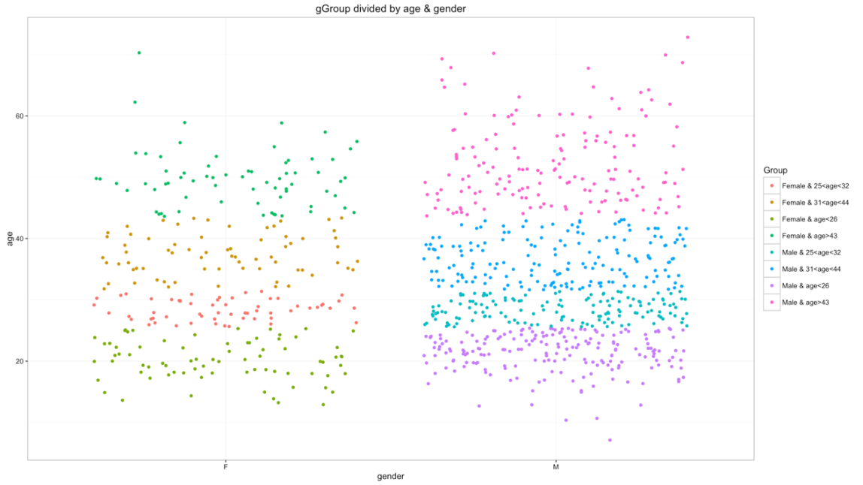

Figure

Divide new users with personal information into 8 groups by age and gender

The figure 2 presents an intuitively grouping by dividing the old users into 8 clusters according to their age (Quantiles) and gender (Male & Female). It makes sense because we believe that age and gender would have big influence on the recommend list. For example, young age people would give higher ratings on Animation movies while Drama may not be appeal to this age group. Also female may prefer Romance movies to Fiction movies. Though occupation may have some effects on the recommend list, two people may have similar preference with same age and gender even their occupation are not the same.

Therefore, if we know new user’s age and gender, we will recommend movies based on the ratings of old users that are in the same group. Find out those movies that are popular and high-rating for this group, make recommendations to the new users. Similarly, if we only know the new user’s age (gender), then we will recommend movies based on all the group members that have the same age (gender). If we only know new user’s occupation, we will recommend movies according to all the old users in the rating dataset with same occupation.

Here, we use an example to explain the second method.

Assuming a new user, who has age =20, gender =Female, occupation = student, and we know all/part information of her.

|  |  |  |  |  |  |  |  |  |  |  |  |  |
| --- | --- | --- | --- | --- | --- | --- | --- | --- | --- | --- | --- | --- |
| **Personal Information** | | | **Recommending movies’ ID** | | | | | | | | | |
| **age** | **gender** | **occupation** | **movie1** | **movie2** | **movie3** | **movie4** | **movie5** | **movie6** | **movie7** | **movie8** | **movie9** | **movie10** |
| **20** | **F** | **student** | **5** | **276** | **1104** | **1217** | **1283** | **1319** | **1400** | **1509** | **1575** | **1655** |
| **20** | **F** | **NA** | **5** | **276** | **1104** | **1217** | **1283** | **1319** | **1400** | **1509** | **1575** | **1655** |
| **NA** | **F** | **student** | **276** | **306** | **1104** | **1217** | **1283** | **1319** | **1331** | **1400** | **1509** | **1575** |
| **20** | **NA** | **student** | **5** | **276** | **306** | **321** | **1217** | **1283** | **1319** | **1400** | **1575** | **1655** |
| **NA** | **NA** | **student** | **276** | **306** | **321** | **1217** | **1283** | **1319** | **1400** | **1509** | **1575** | **1655** |

Table

The test results for one user with age=20, gender=Female, occupation=student, while we know all or partly characteristics of her.

According to table 1, the recommend lists will be identical for users of same age and gender, no matter what occupation it is. And there is slightly difference when we only know one of the characteristics, i.e. age, gender and occupation.

Using R, the Recommend list for new users with age =20 & gender =Female are:

* One Flew Over the Cuckoo's Nest (1975)
* 12 Angry Men (1957)
* Usual Suspects, The (1995)
* Shawshank Redemption, The (1994)
* Wrong Trousers, The (1993)
* To Kill a Mockingbird (1962)
* Star Wars (1977)
* Rear Window (1954)
* Casablanca (1942)
* Schindler's List (1993)

1. **Old Users**

**Reference**

[1] Linden G, Smith B, York J.Amazon.com Recommendations: Item-to-Item Collaborative Filtering. IEEE 2003.p. 76-80.

[2] [Kaushik Pal](http://www.kdnuggets.com/author/kaushik-pal), TechAlpine, “How big data is used in Recommender Systems to change our lives”.

[3] Jyoti, Dhawan S, Singh K. Analyzing User Ratings for Classifying Online Movie Data using Various Classifiers to Generate Recommendations. In proc. ABLAZE, IEEE 2015.p. 295-300

[4] Michael D. Ekstrand, John T. Riedl and Joseph A. Konstan, “Collaborative Filtering Recommender Systems”.

[5] Balabanovic, M., Shoham, Y.: Fab: Content-based, Collaborative Recommendation. Communications of the ACM 40(3), 66–72 (1997).

[6] Paul Resnick and Hal R. Varian, “Recommender systems. (Special Section: Recommender Systems)” Communications of the ACM, March 1997 v40 n3 p56(3)

[7] Pasquale Lops, Marco de Gemmis and Giovanni Semeraro, “Content-based Recommender Systems: State of the Art and Trends” © Springer Science+Business Media, LLC 2011.

[8] Sanjeev Dhawana , Kulvinder Singhb , Jyotic, “High Rating Recent Preferences Based Recommendation System”, Procedia Computer Science 70 ( 2015 ) 259 – 264.

[9] Francesco Ricci, Lior Rokach and Bracha Shapira, “Introduction to Recommender Systems Handbook”, Accessed from web on April 2, 2016.

[10] Jyoti, Dev P, Dhawan S, Singh K. Automotive Tools for Making Effective Recommendations for E-commerce Websites: An In-depth Comparative Study. IOSR-JCE 2015. p. 53-58.

[11] Robin Burke, California State University, Fullerton Department of Information Systems and Decision Sciences, “Hybrid Recommender Systems: Survey and Experiments”.

[12] Chuang H, Wang L, Pan C.A Study on the Comparison between Content-based and Preference-based Recommendation Systems. In proc. SKG, IEEE 2008.p. 477-480.